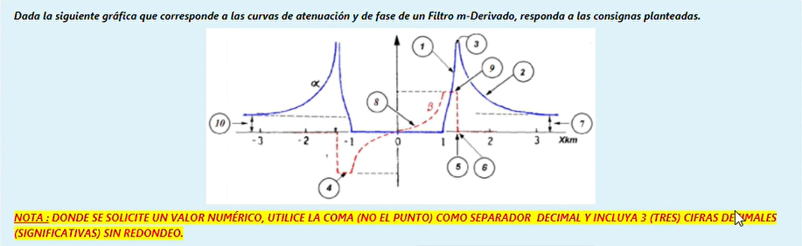

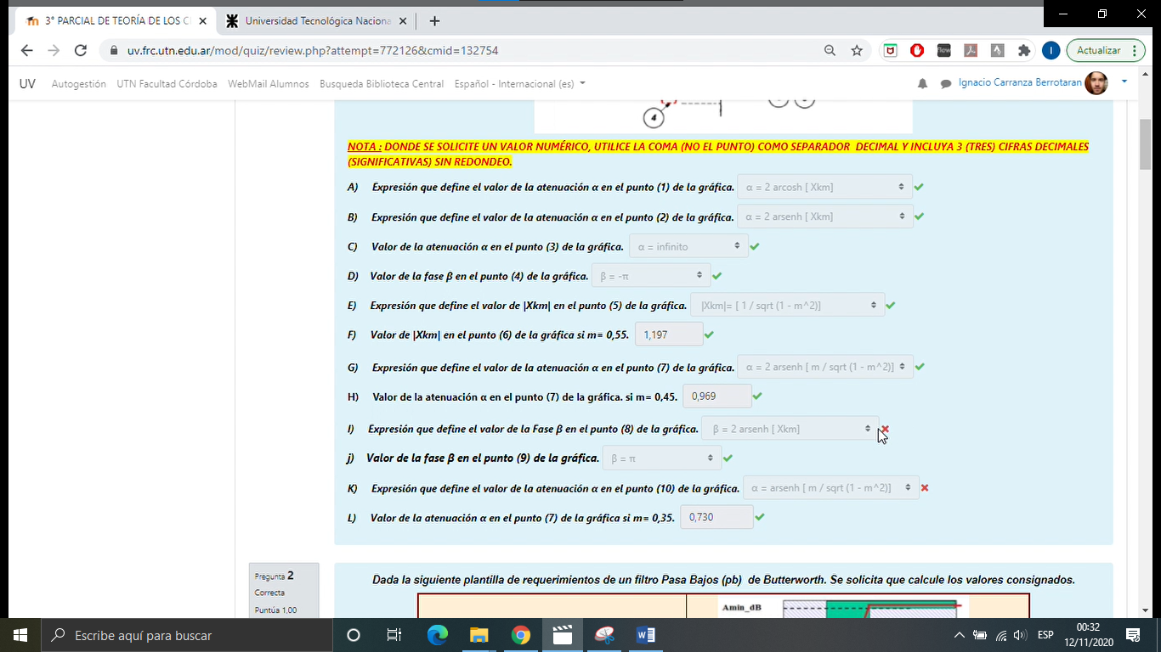

β=2 arsen [Xkm]

